**How to add and publish Custom fields**

1. Go to Desired form :

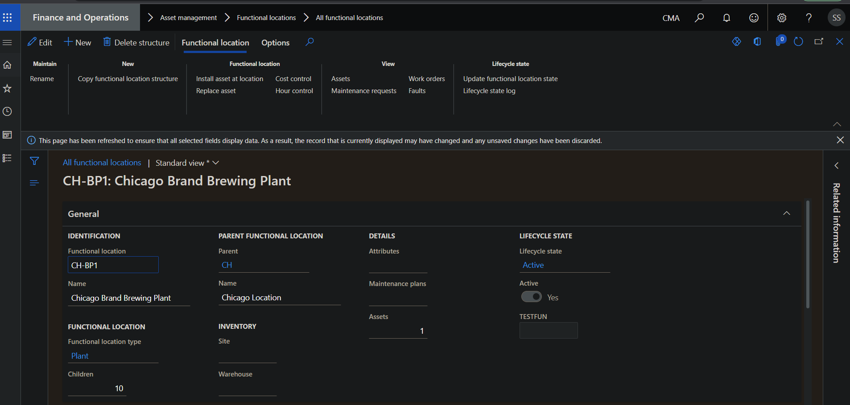

1. Right click on form & select Personalize General :

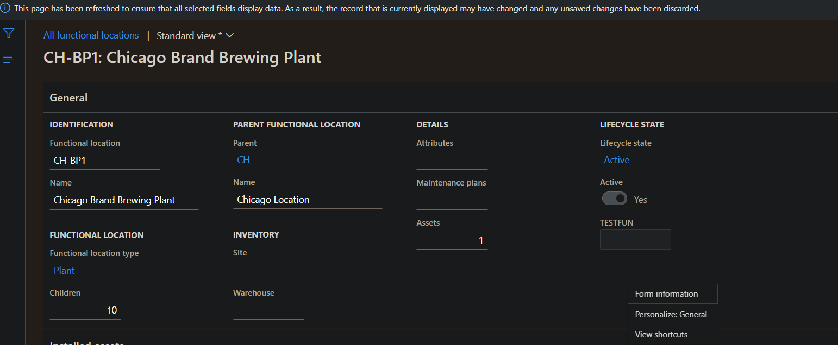

1. Add a field :

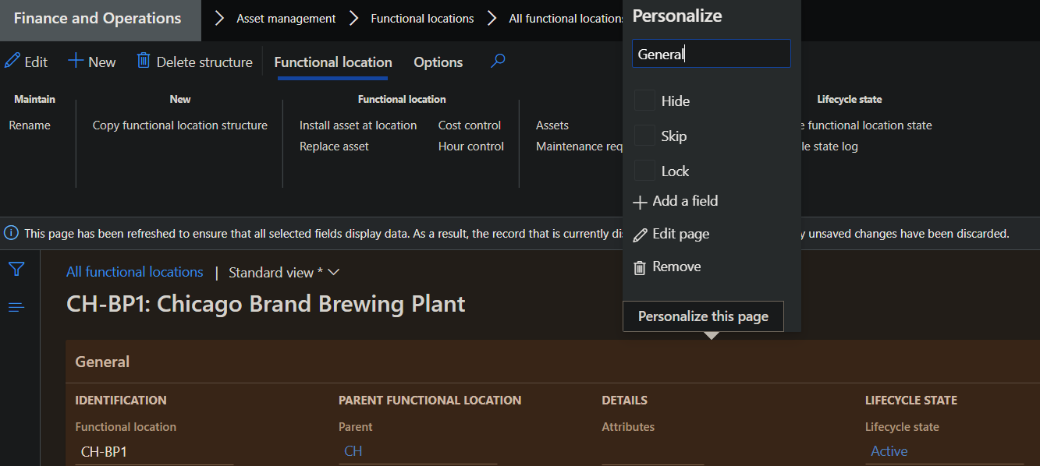

1. Select Create new field :

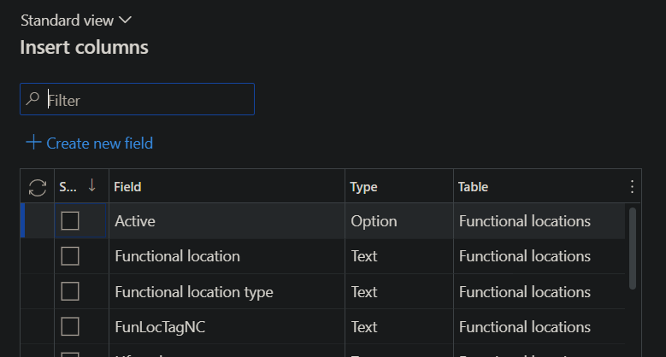

1. Provide Details(Table name ,Name prefix ,Data type ,Label ,Help text ,Limit) :

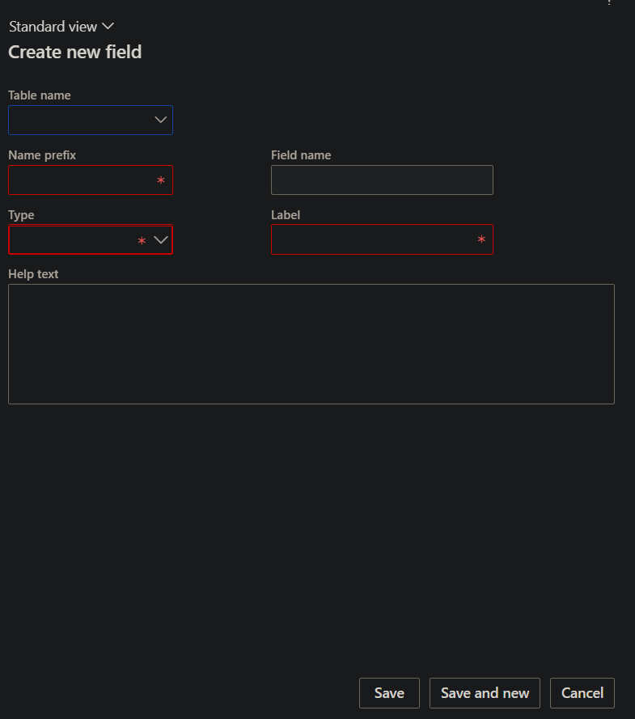

1. Save & Update.
2. Save as View(optional to add data in custom field) :

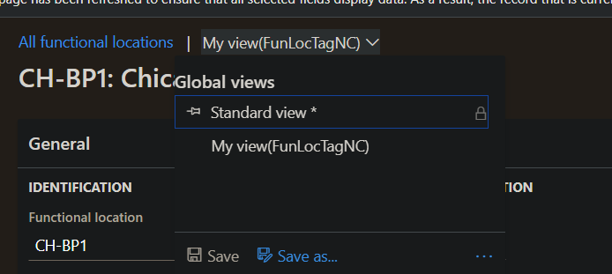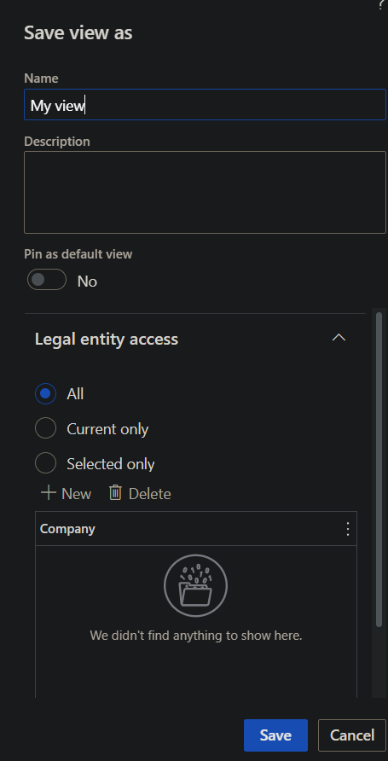

1. Go to Custom fields(in search) & Select Desired System name :

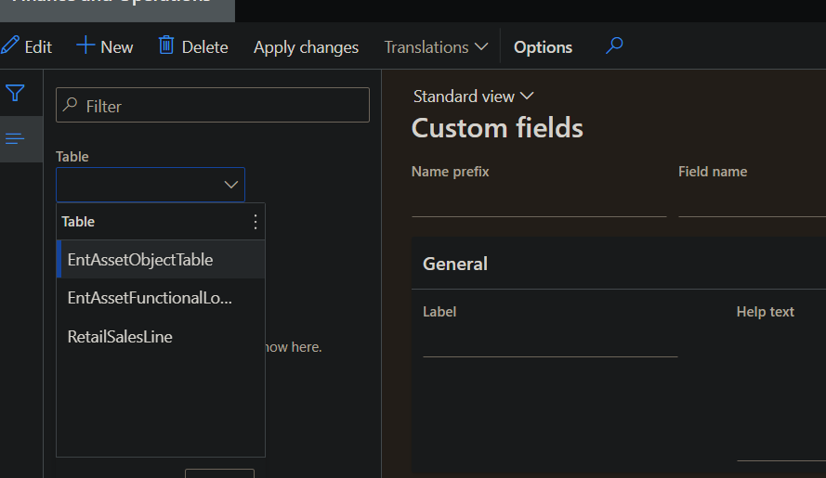

1. Click on Edit & select desired entities which are bound to selected table in which you want to add column :

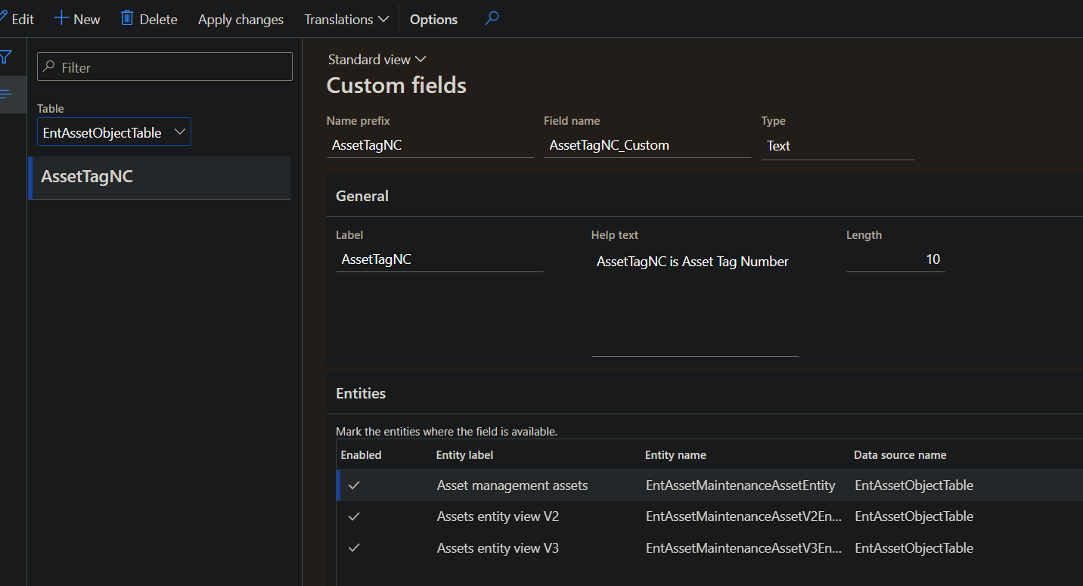

1. Click on Apply changes & Save :

